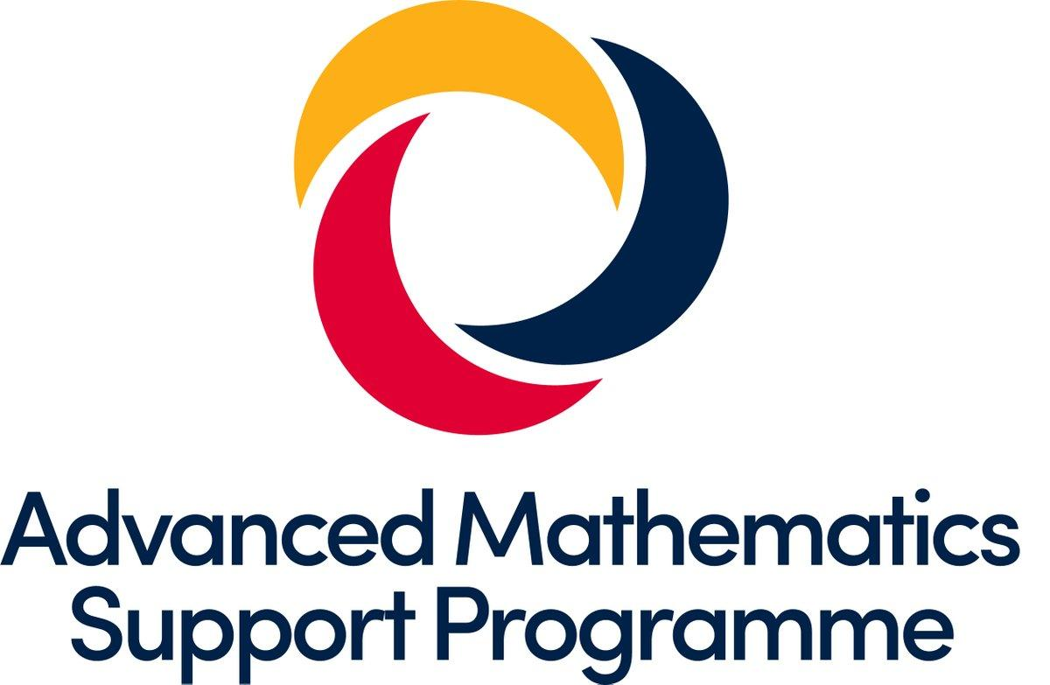
Supporting Core Maths
for all current and potential teachers of Core Maths

Overview
This Network Collaborative Project is designed and run by the Boolean Hub in association with the Advanced Maths Support Programme and the GLOW Hub and is aimed to provide sustained professional development for Core Maths Teachers. It is a contribution to the wider national effort to increase the profile of Core Maths in particular and participation in Level 3 qualifications in general.

Who is it for?
All current and potential teachers of Core Maths.

What does it involve?
Three afternoon/twilight meetings in the spring of 2019. See dates and location below. There will be gap tasks and a commitment to sharing good practice and developing your skills. Participants will work collaboratively with colleagues from other schools in a school-to-school support model with the aim for long-term links to be made with like-minded colleagues in the area.

What is the specific focus?
The group will primarily look at pre-release materials from all the relevant boards (depending on participants) and develop strategies for best preparing students for the exams in the summer of 2019.
In addition to this, there will be an opportunity to look at cross curricular resources to support the teaching of Core Maths.

It is important that everyone gets something out of their participation and we will work hard as work group leaders to ensure that additional specific support is given where possible.

Funding
The cost of this work group is funded by the Maths Hub and so is free to schools. Please note that schools will need to cover their own cover costs, and a non-attendance without notification may carry an administration charge per session missed.

Dates: Wednesdays 13th February, 6th March, 19th June

Sessions will take place from 2pm to 5pm at St Bede’s Catholic College, Long Cross, Bristol BS11 0SU

To reserve your place on this work group please email Boolean Maths Hub for the online booking link at

BooleanMathsHub@clf.cabot.ac.uk

School Commitment:
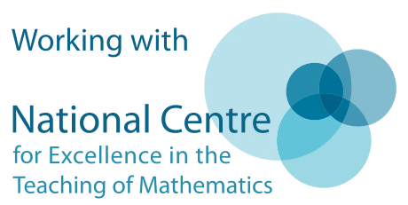
As part of the conditions of booking, school senior leadership will commit to the release of the same nominated teacher(s) for all four workshops and to support them in completing the gap tasks, wider staff and departmental engagement, between each workshop. The department will also support the participating teachers to summarise the impact of Work Group participation as part of the professional development and Work Group evaluation.

